3 Phase Rectifier with Resistive Load

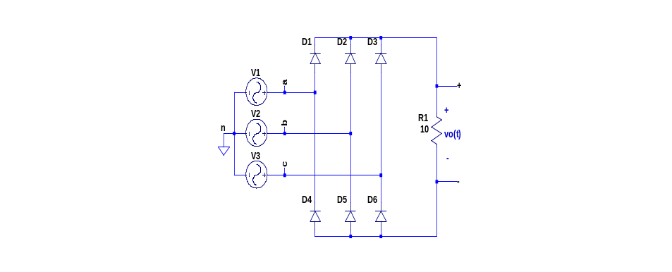
Voltage Waveforms:
Line to Neutral Voltages:
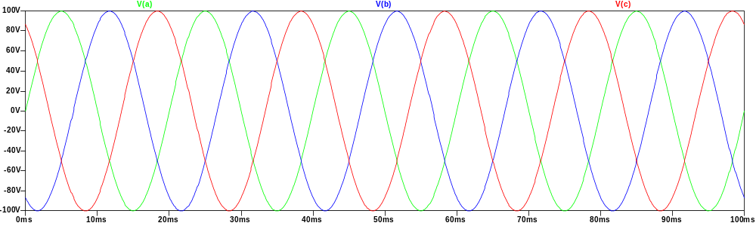
D1,D2,D3 select the highest positive voltage for Output + while D4,D5,D6, select the lowest negative voltage for Output - :
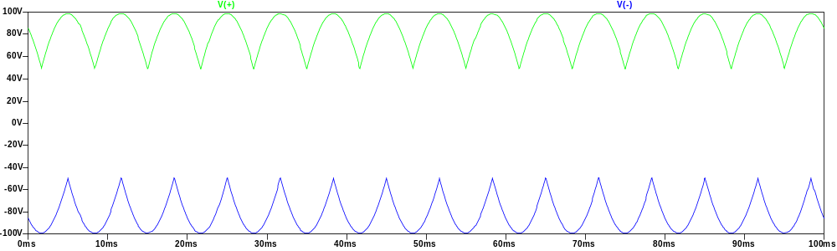
The output voltage is the difference between these two: Please compare the output voltage with eth line to neutral voltage Van and the line to line voltage Vab, The ouput voltage rides along the peaks of the line to line voltages. The output voltage has six ripple pulses per cycle. This is often called a six pulse rectifier.
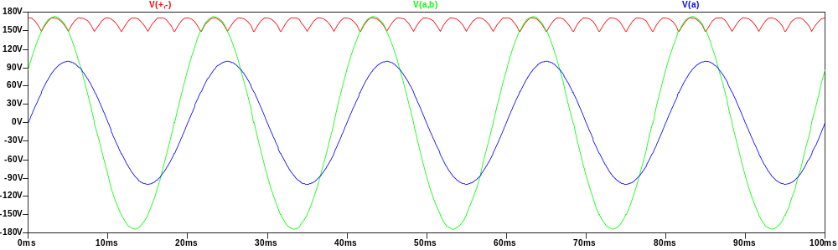
Current Waveforms:
The output current follows i_{o}(t) follows the voltage across the resistor:
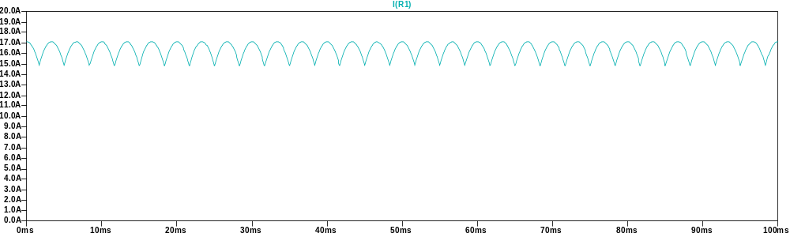
When Van is the highest phase voltage D1 conducts and the load current flows out of phase a supplies the load current. When Van is the lowest phase voltage D4 conducts and the load current flows back into Phase a. It is important to note taht only one top diode conducts at a time and only one bottom diode conducts at a time. The following plot shows the currents in D1 and D4 overlayed onto the Van waveform.
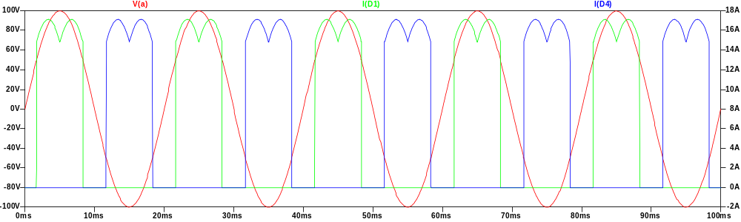
And the AC current i_{a}(t) looks like:
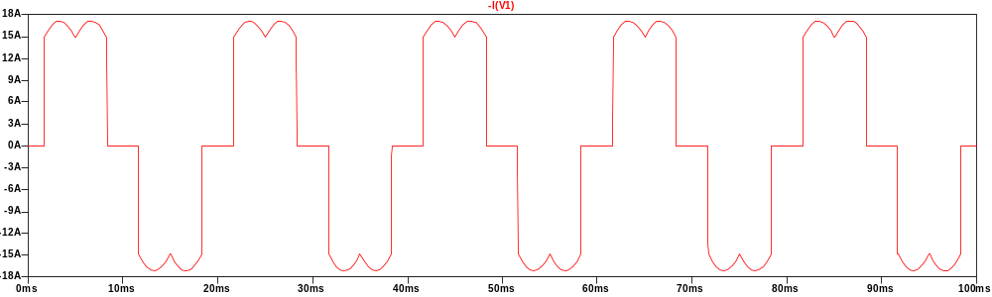
For reference notice how the three ac currents I_{a}, I_{b} and I_{c} line up to provide a continuous outward and return path for the load current:
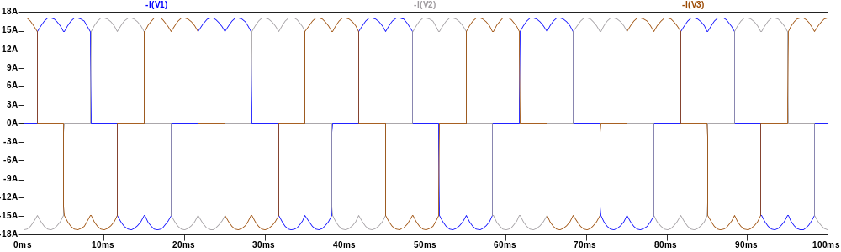
Analysis of 3 phase rectifier with resistive load:
Notation: Let V_{m} = Peak line to neutral voltage
Useful Integration formula: 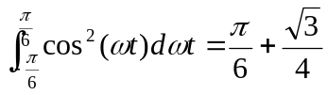
1. Peak Output Voltage = peak of the line of line voltage = 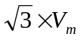

2. Average Value of the output voltage may be got by averaging over a single output pulse and using the fact that the output voltage follows a line to line voltage waveform for each pulse. 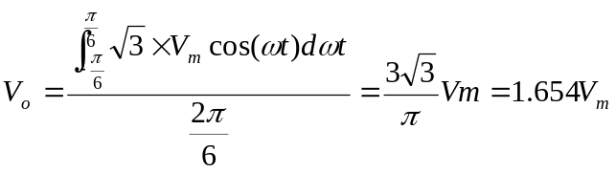

3. Similarly we can calculate the rms output voltage by integrating over a single pulse:
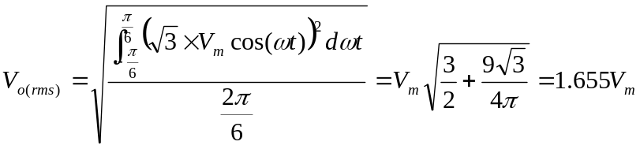

4. Since the output current for a resistive load is just v_{o}(t)/R we can now calculate the rectification ratio (efficiency)
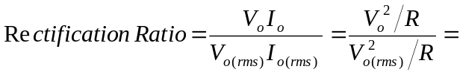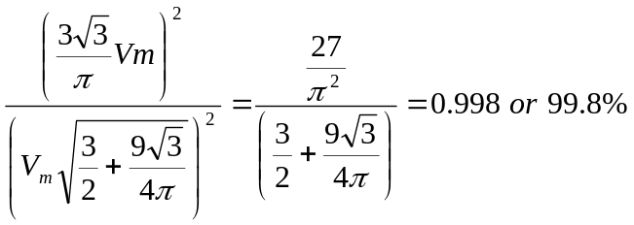

5. In order to calculate the ripple factor we must extract the ac component from V_{o} using the relationship: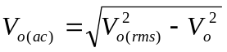
The Ripple factor = 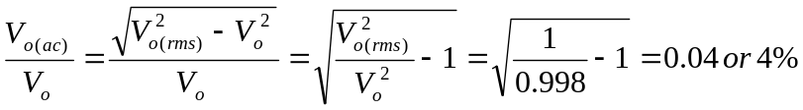
6. In order to calculate the transformer utilisation factor we need to calculate the rms supply current. The easiest way to do this is to notice that ac input current waveform is comprised of four pulses of width 2π/6 over a single cycle of width 2π (remember that positive and negative current contributes equally to the rms).
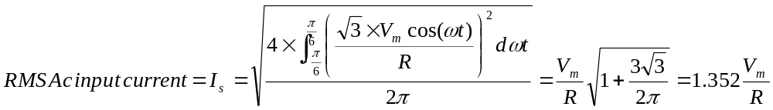
Three Phase Rectifier with highly inductive load.
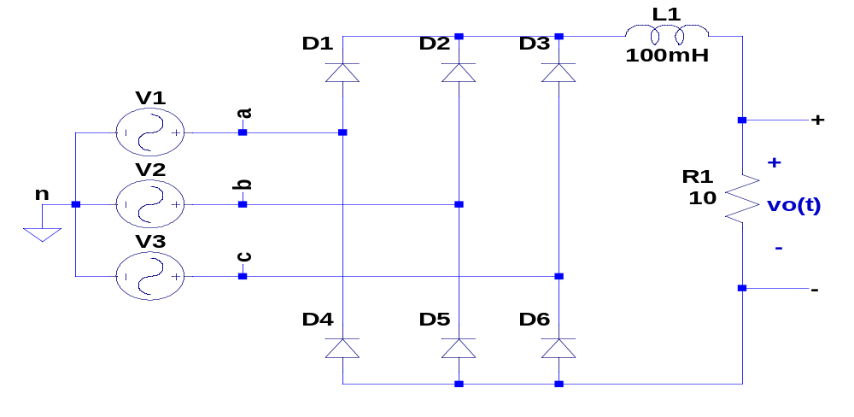

The ripple frequency in a six pulse rectifier is 6xf where f is the mains frequency. The cut off frequency of an LR filter is 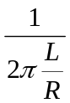. If this cut off frequency is much lower than the ripple frequency i.e. if 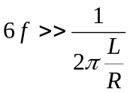 then the ripple will be almost entirely eliminated leaving a smooth DC load current. The output voltage becomes equal to its average DC value.

Voltage Waveforms:
Plot showing V_{an,} V_{ab} and v_{o(t)}
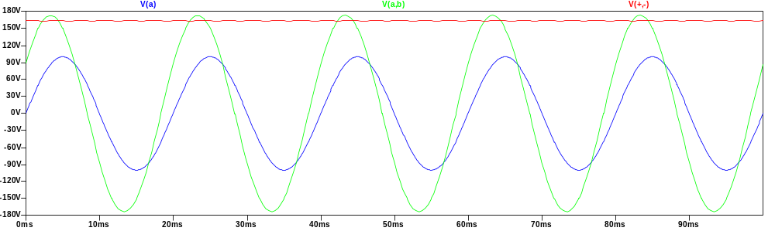

The smooth DC output voltage results in a pure DC output current so the diode currents become square pulses and the input ac current is also "squared up".
Current Waveforms with Inductive Load:
Output Current i_{o}(t)
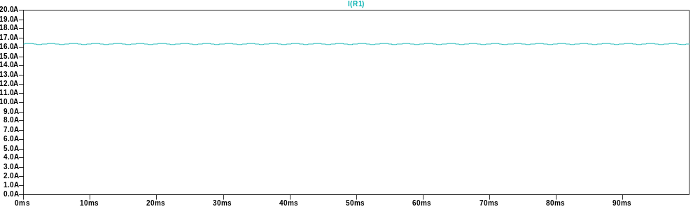

Diode Current Waveforms for D1 and D4. Notice how much squarer these are than the corresponding waveforms for a resistive load:
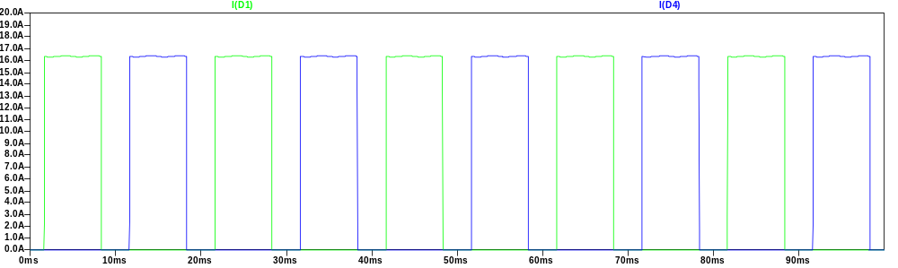

AC input current for phase a shown with line to neutral voltage for reference:
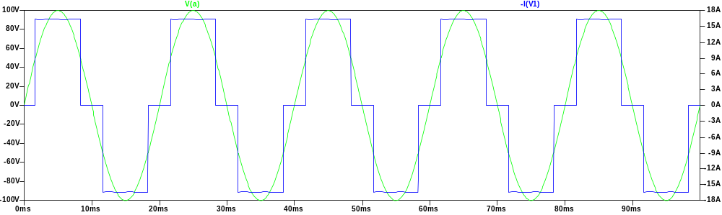

And all three ac currents are shown meshing together in the next graph:
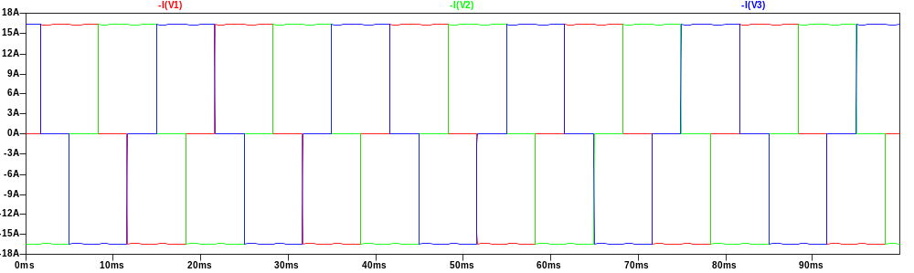
Analysis of 3 phase rectifier with highly inductive load:
Notation: Let V_{m} = Peak line to neutral voltage

1. Peak Output Voltage = average output voltage = the average of the unfiltered output voltage of the rectifier = 1.654V_{m} from before

2. Average Value of the output voltage is the same as before (the inductore attenuates ripple but does not affect average output voltage)

3. The rms output voltage is trivial in this case because there is no ripple
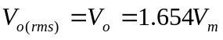

4. Since the output current for a resistive load is just v_{o}(t)/R we can now calculate the rectification ratio (efficiency)
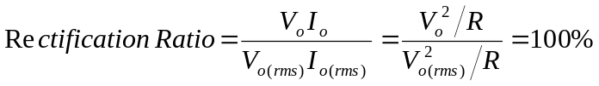

5. Since the ripple is vanishingly small 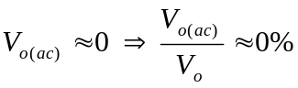
6. In order to calculate the transformer utilisation factor we need to calculate the rms supply current. The easiest way to do this is to integrate over a half cycle. In each half cycle there is a square pulse of current of width 2π/3 and amplitude = I_{o} = 1.654V_{m}/R
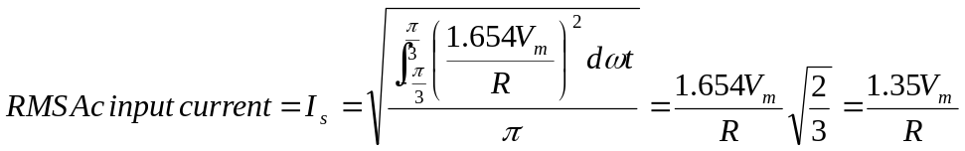
Transformer Utilisation Factor = 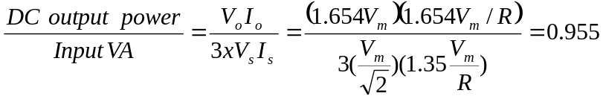

Conclusion: The three phase bridge rectifier with resistive load has significantly lower output voltage ripple and significantly better transformer utilisation than an unfiltered single phase bridge rectifier. The addition of a sufficiently large filtering inductor can result in negligible output voltage ripple but does not substantially improve transformer utilisation over the unfiltered three phase rectifier,

